1. Design NFA using simulator to accept the string that start and end with different symbols over the input {a,b}.

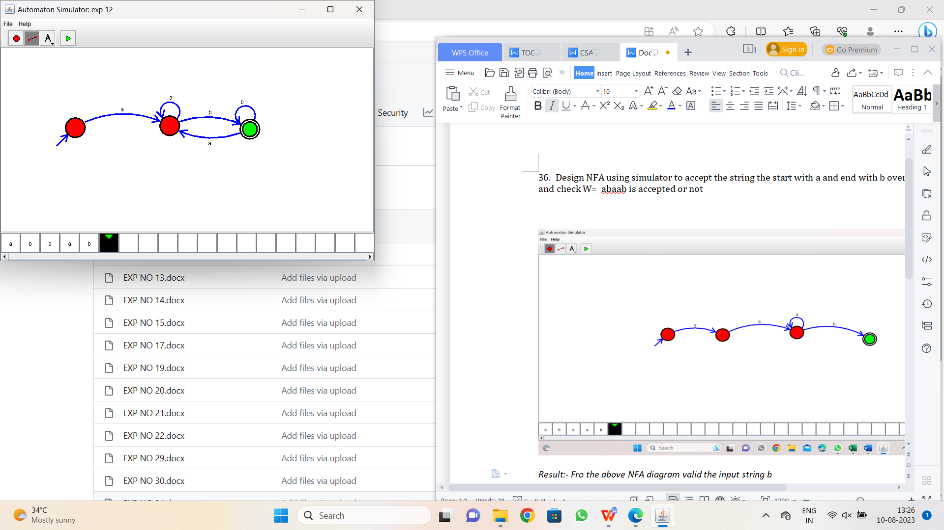

Result:-

From the above NFA diagram valid string starts and enda with different symbols